Wine Quality Prediction

Student’s Name
Institution Affiliation
Abstract
Product quality certificates are used in all industries for marketing purposes. However, this review requires experts, which is time-consuming on HUMAN resources, which increases costs. This article describes two ways to classify products using machine learning, including linear regression, neural networks, and vector vectors. Depending on the variable, the target variables of the variable pair are first determined, and then the expected value of the target variable is determined. In order to determine to what extent the target variable depends on independent factors, the linear regression method was used in this study, and then a determining factor calculated from a relationship that has a large impact on the dependent variable was selected. In addition, it uses vector machines and neural networks to predict the values of dependent variables. Wine datasets are used in all tests.
Keywords: wine, datasets, regression, machine learning techniques, dependent variables and independent

Introduction
The quality of wine is one of the biggest challenges in wine production. With extensive knowledge of wine production and especially the chemical composition of wines, experts possess the unique characteristics of wine. On the other hand, experts usually do not consider the price, appearance, origin and condition of a wine when assessing its quality (Waterhouse et al., 2016). The chemical effect on wine increases taste, aroma, color and other properties (Sousa et al., 2014). The properties of wine are described by laboratory physicochemical tests such as magnesium content, phenolic compounds, flavonoids, flavonoids, flavonoids, proanthocyanidins, color intensity, color, OD280 and proline.
research purpose
Here we predict the quality of wine based on a specific characteristic. We use a lot of information about the quality of Kaggle wine. The material has the most important properties that affect the quality of the wine. Using several machine learning models, we predict the quality of wine.
Research Questions
• What are the different qualities of wine?
• Which quality of wine is better for consumption?
• What are the health benefits of wine?
Literature Review

Machine learning technologies
Machine learning is an artificial intelligence (AI) industry that has existed since the 50s of the twentieth century and is currently disappearing. Modern information technology can solve mathematical equations and improve machine learning, which increases attractiveness (Bhardwaj et al., 2022). years). Ordinary test equipment can be combined with high-quality materials. Machine learning research focuses on machine learning using only one or more machine learning algorithms to solve real-world problems by dividing them into functionally managed blocks (Jambhulkar and Baporikar, 2015).The facilitator and colleagues used various machine learning techniques to select the most important characteristics that affect the quality of wines (Dahal et al., 2021)
Data mining
This can be described as a workload of extracting confidential information from databases for research purposes. Database data discovery (KDD) is called data mining. Data mining is widely used in e-commerce, inventory, product analysis, customer market research, understanding real estate investment models, etc.Data mining is based on the calculation of multiple numbers based on mathematical algorithms that are necessary to obtain the desired results in the field of library inventory (More, 2022). Data mining usually involves data collection and analysis, data acquisition, and so on. Software can be the best choice for data mining because it saves time and effort. Available text software technologies, LexiQuest, Megaputer Text Analyzer, Machine Linkers, SAS Text Miner, Lextek Engineer Profiling, and WordStat are popular data mining programs (Zaveri and Joshi, 2017). Data mining helps you get accurate and reliable historical data and predict future events. In addition, companies can use data mining to assess why they need access to the information they need to understand, obtained using business information. Wine Consumption
Gupta and Vanmathi (2021) We attribute this association to moderate wine consumption with greater diversity and health effects. The team found that the types of bacteria in the gut microbiome of drinkers were different from those who did not drink alcohol. Results were also found in three different cohorts in the UK, the US and the Netherlands. The authors examined the age, weight, daily diet, and finances of the participants. Variables as conditions and continue to explore this combination (Waterhouse et al., 2016). years). The authors concluded that since wine is rich in polyphenols, they explain the most important form of this compound. Polyphenols are found as a preservative in many fruits and vegetables. When it comes to the effects of wine on the bulbs of about three thousand people in three different countries, they found that the polyphenols in grape skins are responsible for many controversial benefits. Health, such as fruits in moderation. One study also found that wine consumption was associated with lower cholesterol levels and "bad" cholesterol levels due to the microbe (Jambhulkar and Baporikar, 2015) , similar enough to reveal the effect.
Data collection and processing
This report uses the fault of the Kaggle archive dataset, which contains datasets from multiple machine learning communities. The wine dataset contains 179 wine datasets. The data is determined using ten input variables (based on physical and chemical tests).The quality of sensory recognition is achieved at ten quality levels, 0-10 (0 – worst – 10 – excellent).
Feature Selection
Feature selection is the best way to select categorical elements (Fauzi et al., 2017). based on concept evaluation and feature selection based on thorough evaluation (Onan and Korukoğlu, 2017). This report provides a better understanding of functions and explores the relationships between functions. For each item, a correlation coefficient is calculated, which is a pair of human coherence coefficients P calculated according to the following formula (Dastmard, 2013).
Px, = cov(X, Y) σX, σy
where σ is the standard deviation of XY and cov is covariance. Correlation coefficients range from -1 to 1. Result 1 means that X and Y can be described by linear equations in between, which means that all data points lie in a straight line. Y increases as X increases, where a value of -1 indicates a strong negative correlation between data points (Pest, 2022). Instead, all data points lie in a straight line, where Y decreases as X increases. Result 0 indicates no correlation between the results (Dastmard, 2013).
Descriptive Summary Statistics
Descriptive Statistic Summary
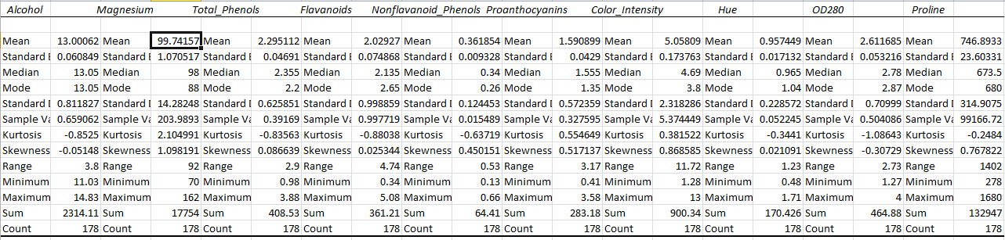
Methods and Data Analysis
This work uses machine learning techniques to determine the degree to which wine quality depends on other quality variables and predictors. This section provides an overview of the proposed approach. Linear regression is then used to determine the relationship between the quality of the wine and ten other independent variables (precursors). Important predictors are then selected based on the quality of the wine as an independent variable. Finally, evaluate the vector machines and neural networks for each predictor you choose, and the wine quality predictions used by the network.
Linear regression
Linear regression is an example of the relationship between a dependent variable and two or more independent variables. They predict the value of a variable based on the values of two or more other variables. Regression models can be repeated
Y = β0 + β1X1 + β2X2 + ∙ ∙ ∙ βk Xk + ε (1), where Y is the response variable and Xi is the predictor (independent variable).
Output the model. β0, β1, β2, ..., βk are regression coefficients.
Artificial Neural Networks.
The neural network implemented in this work has three layers: input, hidden, and output,
In the input layer, Xi is defined as Functions transferred to the hidden layer
DY exp 2 Y( X ) D exp 2 s = - å = - å = - å
where σ is the width of the core.
The output node calculates A/B or Y.
The hidden layer consists of all Xi practice rooms. When an unknown pattern X is visible in this neural network, the square distance between X and each X is calculated.
Di2 = ( X − Xí )T (X − Xí ) This square distance is transferred to the nucleus function, and the additional function then travels these distances.
Experimental Results And Analysis
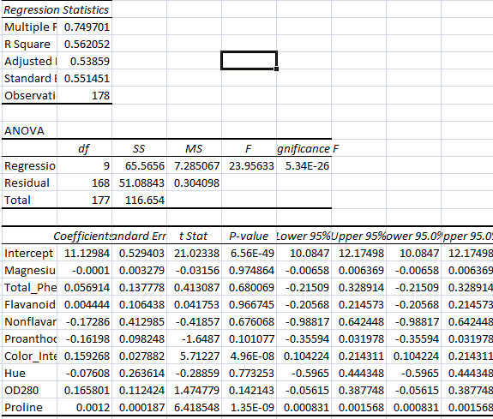
If we let
- Magnesium
- Total_Phenols
- Flavanoids
- Nonflavanoid_Phenols
- Proanthocyanins
- Color_Intensity
- Hue
- OD280
- Proline

Therefore the regression model obtained were as follows,
Y = 11.1298 - 0.0001+ 0.0569 + 0.0044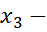 0.1729 - 0.162 + 0.159268
- 0.076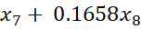 + 0.0012

Results And Discussions
If magnesium content increases by one unit, health benefits fall by 0.0001 units while all other factors are held constant.
If total_phenols happens to increase by one unit, health benefits will increase by 0.0569 units holding other variables fixed.
If flavanoids content in the wine is increased by one unit, health benefits increases by 0.0044 units while all other factors held constant.
If Non flavanoid_Phenols chemicals are increased by one unit, health benefits will fall by 0.1729 units holding other variables fixed.
If Proanthocyanins chemicals are increased by one unit, health benefits will fall by 0.162 units holding other variables fixed.
If Color_Intensity ingredient happens to increase by one unit, health benefits will increase by 0.1593 units holding other variables fixed.
If Hue content in the wine is increased by one unit, health benefits fall by 0.076 units while all other factors held constant.
If OD280 chemicals are increased by one unit, health benefits will fall by 0.1658 units holding other variables fixed.
If Proline chemicals are increased by one unit, health benefits will increase by 0.0012 units holding other variables fixed.
From the report we observed that the model was F calculated was greater than F significance. We therefore rejected the null hypothesis and concluded that the model was significant.
Using the scattered diagram approach, we found out that there exists a positive correlation between the wine consumption and health benefits as shown in the following diagram,
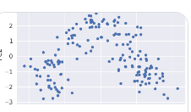

Conclusion
Over the years, interest in the wine industry has increased, which requires the development of this industry. To enhance wine production and sales, businesses are investing in innovative technology. As a result, wine quality certification is crucial to both procedures and necessitates expert alcohol control. In this article, two different applications of machine learning are discussed. First, how neural networks and vector machines predict values; second, how linear regression determines the anticipated values. A collection of pigs' comparison data was used in each trial. Red wine and white wine are the two categories that make up the latter. There are 1599 samples of red wine and 4898 of white wine. The material contains 12 physicochemical properties of red and white wine. 1 (mass) is a dependent variable, the second is predictor 11.Experiments have shown that if only important elements are taken into account in the prediction, and not all, the value of the dependent variable can be predicted more accurately. In the future, it will be possible to use experiments on big data and explore other machine learning techniques to predict wine quality.

References
Bhardwaj, P., Tiwari, P., Olejar Jr, K., Parr, W., & Kulasiri, D. (2022). A machine learning application in wine quality prediction. Machine Learning with Applications, 8, 100261.
Canizo, B. V., Escudero, L. B., Pellerano, R. G., & Wuilloud, R. G. (2019). Data mining approach based on chemical composition of grape skin for quality evaluation and traceability prediction of grapes. Computers and Electronics in Agriculture, 162, 514-522.
Dahal, K. R., Dahal, J. N., Banjade, H., & Gaire, S. (2021). Prediction of wine quality using machine learning algorithms. Open Journal of Statistics, 11(2), 278-289.
Dastmard, B. (2013). A statistical analysis of the connection between test results and field claims for ECUs in vehicles.
Fauzi, M. A., Arifin, A. Z., Gosaria, S. C., & Prabowo, I. S. (2017). Indonesian news classification using naïve bayes and two-phase feature selection model. Indonesian Journal of Electrical Engineering and Computer Science, 8(3), 610-615.
Gupta, M., & Vanmathi, C. (2021). A Study and Analysis of Machine Learning Techniques in Predicting Wine Quality. International Journal of Recent Technology and Engineering, 10.
Jambhulkar, P., & Baporikar, V. (2015). Review on prediction of heart disease using data mining technique with wireless sensor network. International Journal of Computer Science and Applications, 8(1), 55-59.
Mor, N. S. (2022). Wine Quality and Type Prediction from Physicochemical Properties Using Neural Networks for Machine Learning: A Free Software for Winemakers and Customers.
Onan, A., & Korukoğlu, S. (2017). A feature selection model based on genetic rank aggregation for text sentiment classification. Journal of Information Science, 43(1), 25-38.
Sousa E.C., UchôaThomaz A.M.A., Carioca J.O.B., de Morais S.M., de Lima A., Martins C.G., Alexandrino C.D., Ferreira P.A.T., Rodrigues A.L.M., Rodrigues S.P., Silva J.do N., Rodrigues L.L. (2014).Chemical composition and bioactive compounds of grape pomace (Vitis vinifera L.), Benitaka variety, grown in the semiarid region of Northeast Brazil Food Science and Technology, 34 (1) (2014), pp. 135-142,
Waterhouse, A. L., Sacks, G. L., & Jeffery, D. W. (2016). Understanding wine chemistry. John Wiley & Sons.
Zaveri, S. H., & Joshi, N. (2017). A Comparative Study of Data Analysis Techniques in the domain of Medicative care for Disease Predication. International Journal of Advanced Research in Computer Science, 8(3).

